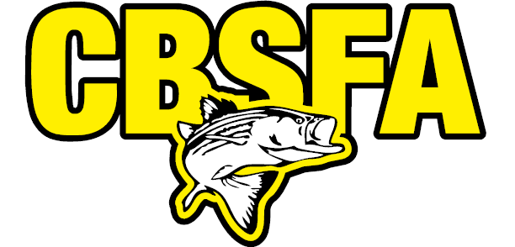
2019 Calendar of Events
May 3-5 CBSFA Spring-Bling Rockfish Tourney
June 15th CBSFA Schools-Out Rockfish Tourney
June 21-23 CBSFA O.C. Tuna-Fortuna Tourney
July 6th CBSFA O.C. FLOUNDER SOUNDER
July 13th CBSFA St. Jude White Perch Tourney
August 24th CBSFA “End of Summer” Rockfish
September 14th CBSFA O.C. Flounder “Fall-Haul” Tourney
November 9-10 CBSFA Fall-Squal Rockin Tourney
Contact: Joe Thorpe jthorpe@cbsfa.club or 410-868-5488

